*Compte rendue*

*: Base de données*

*Mini projet web*

*Equipe 8 LGLSI2D*

* **Le modèle conceptuel**

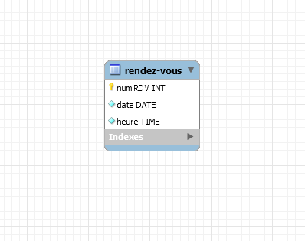

-- MySQL Script generated by MySQL Workbench

-- Tue May 4 07:47:34 2021

-- Model: New Model Version: 1.0

-- MySQL Workbench Forward Engineering

SET @OLD_UNIQUE_CHECKS=@@UNIQUE_CHECKS, UNIQUE_CHECKS=0;

SET @OLD_FOREIGN_KEY_CHECKS=@@FOREIGN_KEY_CHECKS, FOREIGN_KEY_CHECKS=0;

SET @OLD_SQL_MODE=@@SQL_MODE, SQL_MODE='ONLY_FULL_GROUP_BY,STRICT_TRANS_TABLES,NO_ZERO_IN_DATE,NO_ZERO_DATE,ERROR_FOR_DIVISION_BY_ZERO,NO_ENGINE_SUBSTITUTION';

-- -----------------------------------------------------

-- Schema rdv

-- -----------------------------------------------------

-- -----------------------------------------------------

-- Schema rdv

-- -----------------------------------------------------

CREATE SCHEMA IF NOT EXISTS `rdv` DEFAULT CHARACTER SET utf8 ;

USE `rdv` ;

-- -----------------------------------------------------

-- Table `rdv`.`rendez-vous`

-- -----------------------------------------------------

CREATE TABLE IF NOT EXISTS `rdv`.`rendez-vous` (

`numRDV` INT NOT NULL,

`date` DATE NOT NULL,

`heure` TIME NOT NULL,

PRIMARY KEY (`numRDV`))

ENGINE = InnoDB;

SET SQL_MODE=@OLD_SQL_MODE;

SET FOREIGN_KEY_CHECKS=@OLD_FOREIGN_KEY_CHECKS;

SET UNIQUE_CHECKS=@OLD_UNIQUE_CHECKS;

